Project Design Phase-II
Technology Stack (Architecture & Stack)

Date | 29 September 2026
Team ID | SWTID-2026-7972
Project Name | ComicCraft - AI Comic Story Creator using Gemini Models
Maximum Marks | 4 Marks

Technical Architecture:
The Deliverable shall include the architectural diagram as below and the information as per the table1 & table 2
Idha ComicCraft: AI-powered comic story creation using Gemini models
Guidelines:
Include all the processes (As an application logic / Technology Block)
Provide infrastructural demarcation (Local / Cloud)
Indicate external interfaces (third party API’s etc.)
Indicate Data Storage components / services
Indicate interface to machine learning models (if applicable)
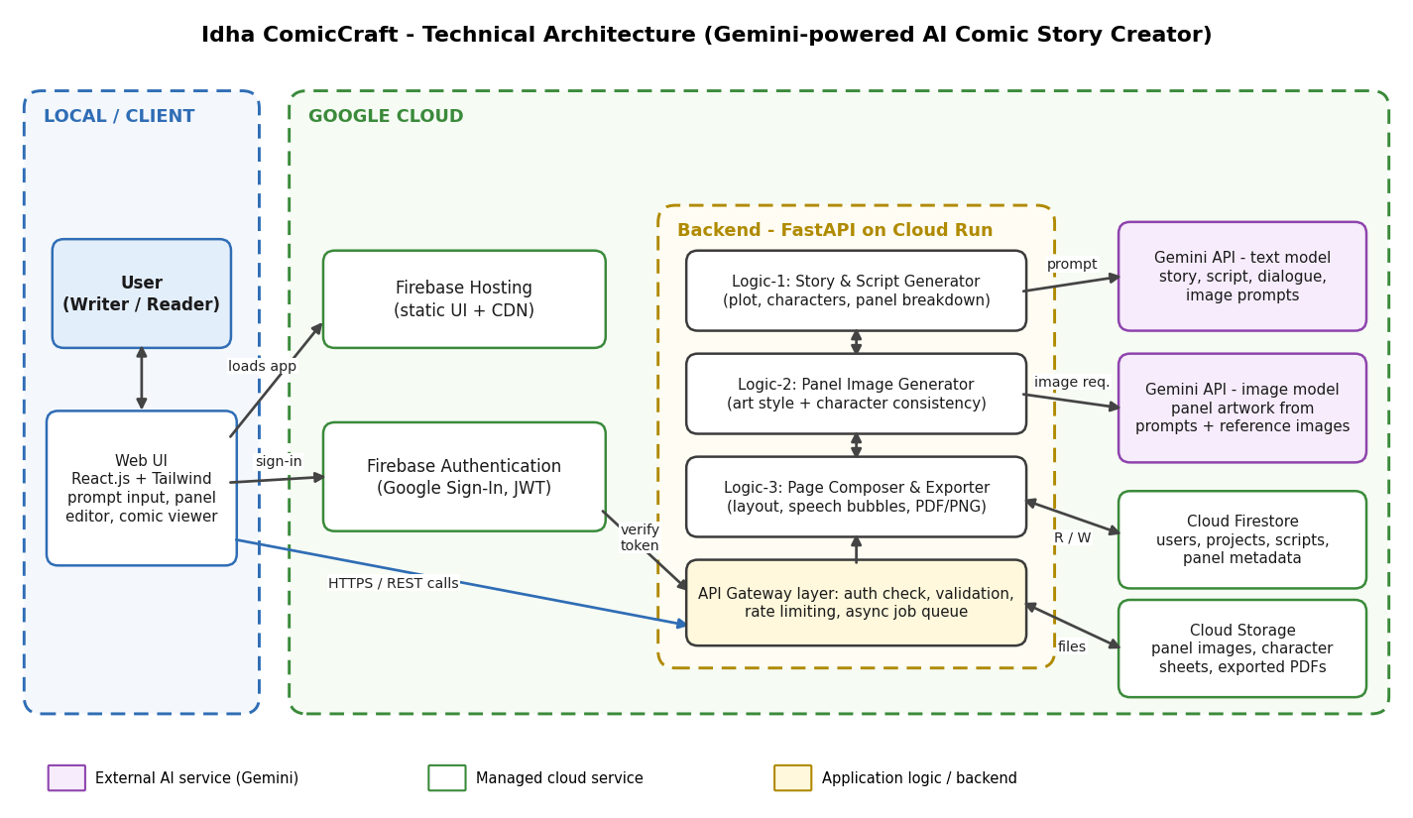

Table-1 : Components & Technologies:
S.No | Component | Description | Technology
 | User Interface | Web application through which the user enters a story idea, chooses characters and art style, reviews and edits the generated script and panels, and reads or downloads the finished comic. | HTML, CSS, JavaScript, React.js, Tailwind CSS
 | Application Logic-1 | Story & script generation: turns the user's idea into a plot, characters, scene-wise panel breakdown, captions and dialogue, and writes an image prompt for every panel. | Python, FastAPI; Gemini text model via Gemini API
 | Application Logic-2 | Panel image generation: creates the artwork for each panel from its prompt, keeping character look and art style consistent by reusing character reference images. | Python, FastAPI; Gemini image-generation model via Gemini API
 | Application Logic-3 | Page composition & export: arranges panels into comic pages, adds speech bubbles and captions, and exports the comic as PDF / PNG. | Python, Pillow, ReportLab
 | Database | Stores users, comic projects, story scripts, panel metadata and prompts as structured / JSON documents (local development setup). | SQLite (local development)
 | Cloud Database | Managed NoSQL database on the cloud for user accounts, projects, scripts and panel metadata. | Google Cloud Firestore
 | File Storage | Storage for generated panel images, character reference sheets and exported comic PDFs. | Google Cloud Storage (local filesystem during development)
 | External API-1 | Gemini API used to call the Gemini text and image models for story, dialogue and panel artwork generation. | Google Gemini API (Google AI Studio / Vertex AI)
 | External API-2 | User sign-in and authentication so each user can only access their own comics. | Firebase Authentication (Google Sign-In)
 | Machine Learning Model | Generative models that write the comic story, script and dialogue (text model) and draw the panel images (image model). | Gemini text model and Gemini image-generation model (pre-trained, accessed through API)
 | Infrastructure (Server / Cloud) | Application deployment on local system / cloud.  Local server configuration: React dev server + Uvicorn (FastAPI) on a developer machine with SQLite.  Cloud server configuration: FastAPI backend in a container on Cloud Run; React UI on Firebase Hosting. | Local; Docker, Google Cloud Run, Firebase Hosting

Table-2: Application Characteristics:
S.No | Characteristics | Description | Technology
 | Open-Source Frameworks | Open-source frameworks used for the UI, backend API and image / PDF handling. | React.js, Tailwind CSS, FastAPI, Uvicorn, Pillow, ReportLab
 | Security Implementations | User authentication with token verification on every request; Gemini API key kept only on the server in a secret manager (never in the browser); HTTPS everywhere; least-privilege IAM roles; input validation and rate limiting; Gemini safety filters to block unsafe story or image content. | Firebase Authentication (JWT), Google Secret Manager, Cloud IAM, TLS/HTTPS, Gemini safety settings, OWASP Top 10 practices
 | Scalable Architecture | 3-tier architecture (React UI, FastAPI backend, Firestore / Cloud Storage data tier). The backend is stateless and runs in containers, so it scales out automatically as users increase; slow image generation runs as background jobs. | Cloud Run autoscaling, Cloud Tasks (job queue), Firestore, Cloud Storage
 | Availability | Managed, multi-zone cloud services keep the app available; UI is served from a CDN; failed or rate-limited Gemini calls are retried with back-off so a single failure does not stop comic generation. | Firebase Hosting (CDN), Cloud Run, Firestore, retry with exponential back-off
 | Performance | Panel images are generated in parallel; story text is streamed to the UI as it is produced; prompts and finished results are cached to avoid repeat Gemini calls; images are compressed and served through a CDN. | asyncio (parallel calls), response streaming, caching, WebP images, Cloud CDN

References:
https://c4model.com/
https://developer.ibm.com/patterns/online-order-processing-system-during-pandemic/
https://www.ibm.com/cloud/architecture
https://aws.amazon.com/architecture
https://medium.com/the-internal-startup/how-to-draw-useful-technical-architecture-diagrams-2d20c9fda90d

